**Assessed Coursework: Producer-Consumer**

Login/Owner: **kn3118**

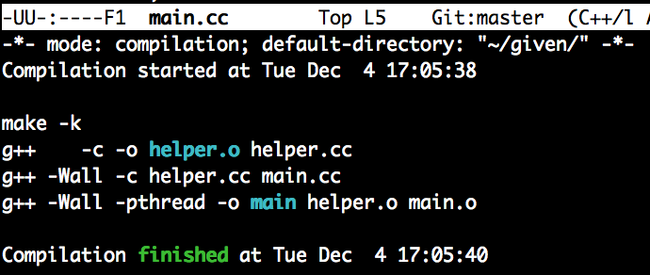

Compilation of the program

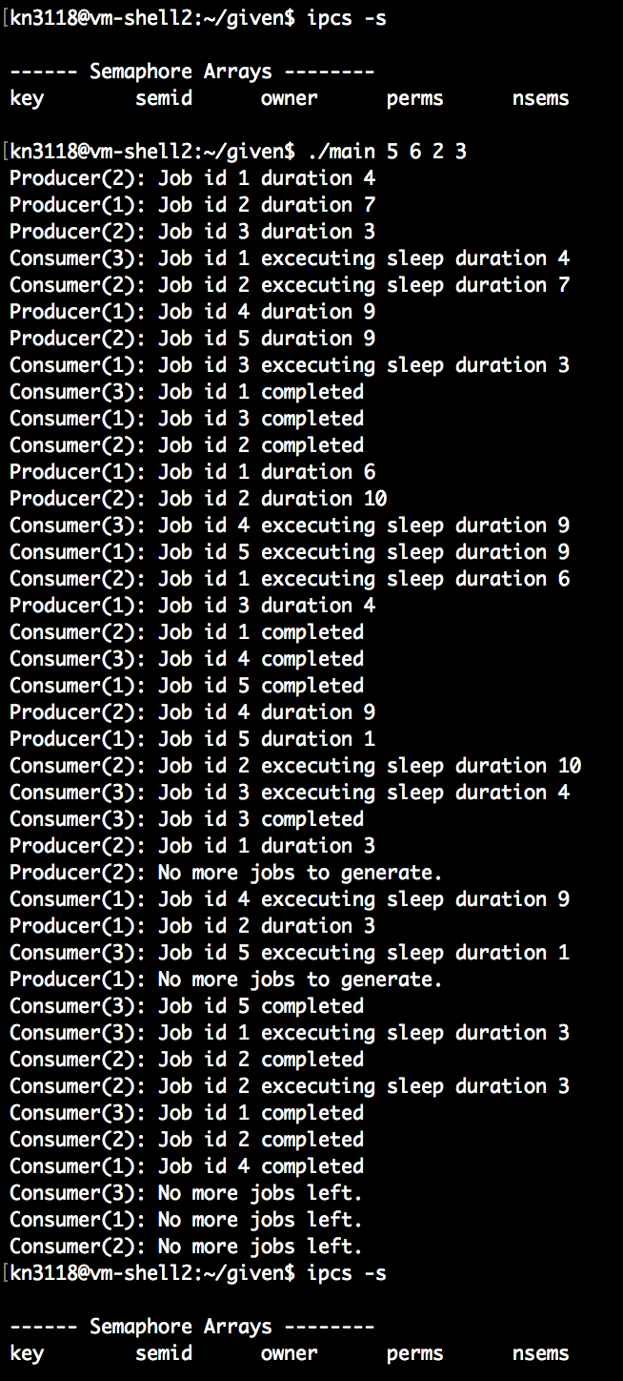

Case 1:

Size of queue = 5

Number of jobs to generate for each producer = 6

Number of producers = 2

Number of consumers = 3

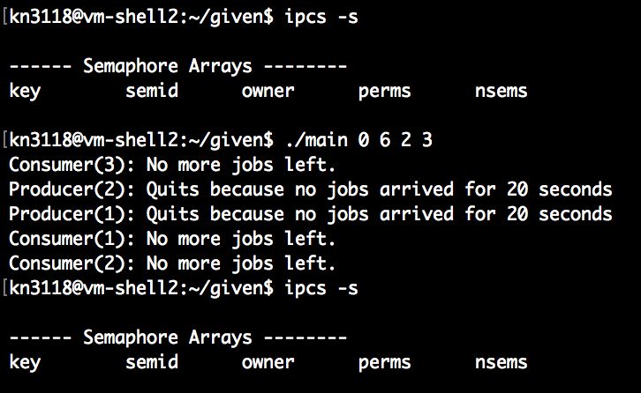

Case 2:

Size of queue = 0

Number of jobs to generate for each producer = 6

Number of producers = 2

Number of consumers = 3

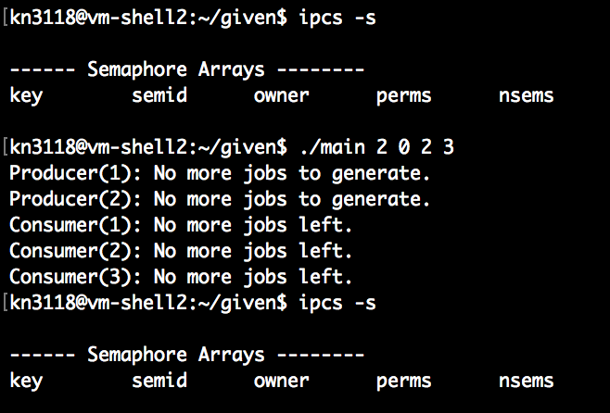

Case 3:

Size of queue = 2

Number of jobs to generate for each producer = 0

Number of producers = 2

Number of consumers = 3

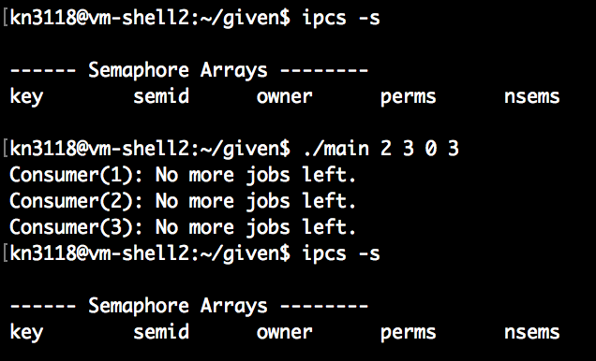

Case 4:

Size of queue = 2

Number of jobs to generate for each producer = 3

Number of producers = 0

Number of consumers = 3

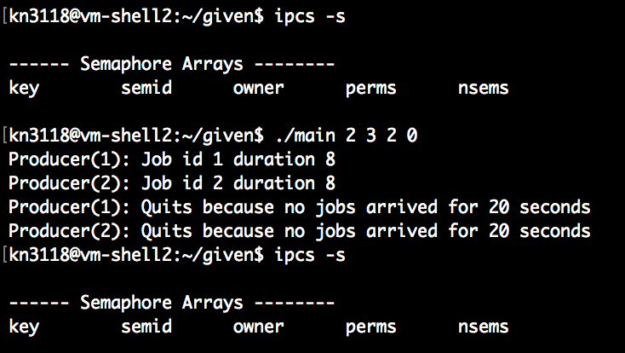

Case 5:

Size of queue = 2

Number of jobs to generate for each producer = 3

Number of producers = 2

Number of consumers = 0

Case 6:

Size of queue = 1

Number of jobs to generate for each producer = 3

Number of producers = 0

Number of consumers = 0

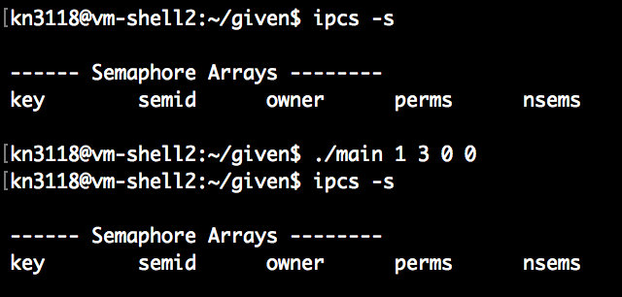

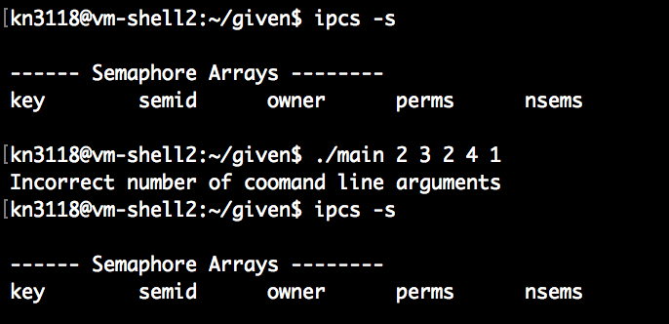

Case 7:

Incorrect number of command line arguments (6 arguments provided)

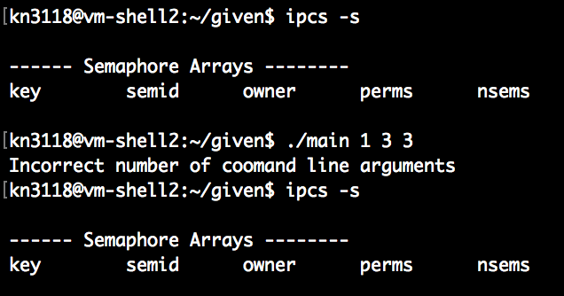

Case 8:

Incorrect number of command line arguments (4 arguments provided)

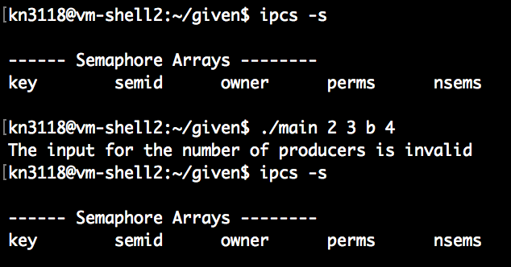

Case 9:

Incorrect command line argument (character value)

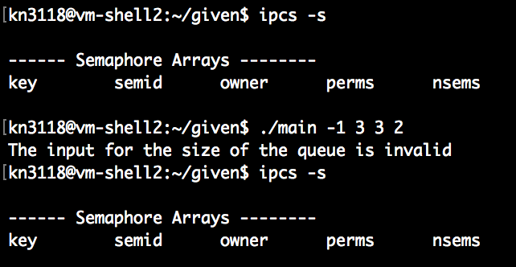

Case 10:

Incorrect command line argument (negative value)

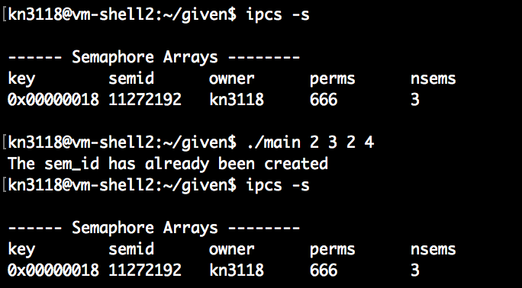

Case 11:

Failure to create the semaphore set with the specific id

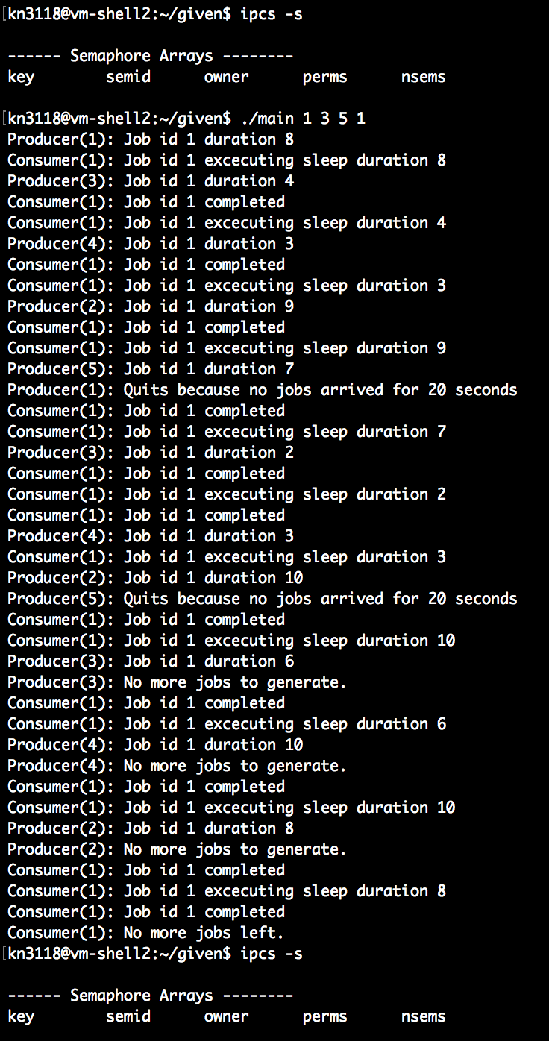

Case 12:

Size of queue = 1

Number of jobs to generate for each producer = 3

Number of producers = 5

Number of consumers = 1

In this example Producer(1) and Producer(5) quit before they produce all their jobs because they could not produce a job for 20 seconds.